COPYRIGHT TRANSFER AGREEMENT FORM
I, the undersigned, on behalf of all authors, hereby declare that the following article is an original work of the author and has never been published in any medium (proceedings, journals, and books).

Name of Principal/Corresponding Author: Apt. Avrilya Iqoranny Susilo, S.Farm., M.Pharm.Sci
Address of Principal/Corresponding Author: Program Studi Farmasi Program Diploma Tiga, Poltekkes Kemenkes Bengkulu (Jl. Indragiri No. 3, Padang Harapan di kota Bengkulu)

Affiliation : Poltekkes Kemenkes Bengkulu
Telephone 082180324545. E-mail: avrilya@poltekkesbengkulu.ac.id

All Author(s) Name:
2. Apt. Nadia Pudiarifanti, M.Sc.
3. Apt. Yoga Dwi Saputra, S.Farm., M.Pharm.Sci.
4. Apt. Mahacita Andanalusia, M.Farm.

Affiliation :
2. Poltekkes Kemenkes Bengkulu
3. Universitas Mataram
4. Program Studi Profesi Apoteker, Universitas Mataram

Date of Submitted: 09 June 2026
Manuscript Title: Pharmacist-Led Pillbox And Pictogram Interventions To Improve Medication Adherence, Blood Glucose Control, And Quality Of Life In Patients With Diabetes Mellitus.

- I/We submit the above manuscript to the Journal Pharmaceutical And Sciences (JPS). I/We certify that the work reported here has not been published before and contains no materials the publication of which would violate any copyright or other personal or proprietary right of any person or entity.
- I/We hereby agree to transfer to Faculty Pharmacy, Tjut Nyak Dhien University as publisher the copyright of the above named manuscript. Copyright includes the exclusive right to reproduce and provide articles in all forms and media, including reprints, photographs, microfilms, and any other similar reproduction, as well as translation. The author still has the right to the following:
- All proprietary rights are other than copyright such as patent rights;
- The right to use all or part of this article in future works of our own such as in books and lectures;
- Make copies of published material to be distributed within the institute where the author works;
- Reusing part or all of the material as a compilation material for further writers' writings;
- Duplicate all or part of the published material for use by the author himself as a classroom instruction or verbal presentation material in various forums.

Print or Type Name and Title of Principal/Corresponding Author here: Apt. Avrilya Iqoranny Susilo, S.Farm., M.Pharm.Sci — Corresponding Author
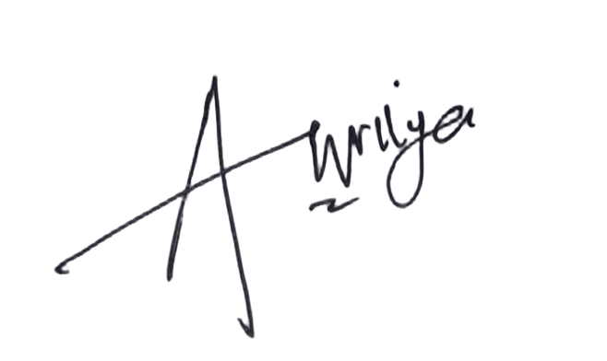
Signature (original) here :

Date : 10 June 2026

Name(s) of Institution/ Organization : Poltekkes Kemenkes Bengkulu

Note: If this article is not received then this letter is declared no longer valid.

